A
Project Report on

An Effective Approach For Hiding Data In Digital Image Using Steganography And Applied Encryption.

Submitted to the partial fulfillment of the requirement for the award of the degree of

BACHELOR OF TECHNOLOGY
IN
COMPUTER SCIENCE & ENGINEERING

Submitted by:
Kamlesh Chag (RA1411003030021)
Anshuman Jha (RA1411003030028)
Aakashdeep Ghosh (RA1411003030068)
Aman Sharma (RA1411003030112)

Supervised by:
Mrs. Madhuri Sharma
Assistant Professor (CSE)



SRM Institute of Science and Technology
NCR Campus, Modinagar

BONAFIDE CERTIFICATE

This is to certify that project Report entitled “An Effective Approach for HIDING DATA IN DIGITAL IMAGE USING STEGANOGRAPHY AND APPLIED ENCRYPTION”, which is submitted by Kamlesh Chag (R1411003030021), Anshuman Jha (RA1411003030028), Aakashdeep Ghosh (RA1411003030068) and Aman Sharma (RA1411003030112) in the partial fulfillment of the requirement for the award of degree B.Tech(CSE) of SRM Institute of Science and Technology, NCR Campus, Modinagar, Ghaziabad is a record of the candidate own work carried out by them under my own supervision.

…………………….........  (Signature) | …..............................................  (Signature)
Dr. R. P. Mahapatra | Mrs. Madhuri Sharma
HOD (CSE) | Supervisor
 | Assistant Professor (CSE)

INTERNAL EXAMINER EXTERNAL EXAMINER

ACKNOWLEDGEMENT
We would also like to express our special thanks to Mrs. Madhuri Sharma, Associate Professor and Project Supervisor of SRM Institute of Science and Technology, NCR Campus, Modinagar, for their insight and knowledge on the subject, who imbued us with the feeling to work assiduously.

We feel compelled to articulate our thankfulness to Dr. Jitendra Singh and Dr. Rajesh Kumar Tyagi, Project Coordinators, SRM Institute of Science and Technology NCR Campus, Modinagar, for his enlightening dexterity which was a perennial source of inspiration.

We would like to express our hearty gratitude to Dr. M. K. Pandey, Director, SRM Institute of Science and Technology, NCR Campus, Modinagar, under whose auspices we were able to work on our project work.

Also, we extend our sincere regards and thanks to Dr. R. P. Mahapatra, Head of the Department, Computer Science and Engineering, & Dean Admission, SRM Institute of Science and Technology, NCR Campus, Modinagar, for his suggestions.

We are also indebted to all the teaching and non-teaching staff members of our college for helping us directly or indirectly by all means throughout the course of our study and project work.

Finally, we take this opportunity to thank our parents, family members and friends for their moral support and help and extended thanks to our well-wishers.

KAMLESH CHAG (RA1411003030021)
ANSHUMAN JHA (RA1411003030028)
AAKASHDEEP GHOSH (RA1411003030068)
AMAN SHARMA (RA1411003030112)
DECLARATION
We, Kamlesh Chag (RA1411003030021), Anshuman Jha (RA1411003030028), Aakashdeep Ghosh (RA1411003030068) and Aman Sharma (RA1411003030112) hereby declare that the work which is being presented in the project report “An Effective Approach for HIDING DATA IN DIGITAL IMAGE USING STEGANOGRAPHY AND APPLIED ENCRYPTION ” is the record of authentic work carried out by us during the period from January ’18 to May ’18 and submitted by us in partial fulfillment for the award of the degree “Bachelor of Technology in Computer Science and Engineering” to SRM IST, NCR Campus, Ghaziabad (U.P.). This work has not been submitted to any other University or Institute for the award of any Degree/Diploma.

Kamlesh Chag (RA1411003030021)
Anshuman Jha (RA1411003030028)
Aakashdeep Ghosh (RA1411003030068)
Aman Sharma (RA1411003030112)
ABSTRACT
With the increase of popularity of image sharing via the platforms on internet and cellular phones thus increasing the importance of encryption. To achieve encryption in an effective manner combination of different algorithms can be used. One of the way to do the same was by rearranging the binary arrangement of the image file and performing swapping on partitions of the same. For decryption process, the rearranged and swapped data of the image will be rearranged with the help of a key and the rest partition swapping will be carried out in the opposite manner as it was done in the encryption process. We are only rearranging the image data, the file size remains the same. The encryption process is very fast thus takes very less time to encrypt as well as decrypt the image. This is the major advantage of using this method. In addition to this, the concept of steganography is also used before the image would undergo through the previously explained process. Before we apply the techniques of zigzag partitioning and swapping, we hide the information to be secured in the image by the technique of steganography using least significant bit algorithm. In the LSB approach, the basic idea is to replace the Least Significant Bits (LSB) of the cover image with the Bits of the messages to be hidden without destroying the property of the cover image significantly. Through this project the image itself is inaccessible along with the message which is hidden by using steganography. The use of Zigzag, partitioning and swapping along with steganography is much complex and the security thus achieved is of higher order.

TABLE OF CONTENTS
1. Introduction
1.1 Network Security……………………….…………………………………………….8
1.2 Cryptograph...………….……………….…………………………………………...10
1.3 Image encryption…..………………….…………………………………………….11
1.4 Steganography …………………….….…………………………………………….12
2. Project scope….........................................................................................................................14
4. Project overview…………………………………….…………………..................................14
5. Global control flow……………………….…………….…………………………………….15
6. Algorithms or methods used
6.1 Steganography encoding and decoding……………………………………………16
6.2 Least significant bit (LSB) insertion method……………..……………………….18
6.3 Convert into binary…………………………………………………………………21
6.4 Partitioning method………………………………………………………………...22
6.5 Zigzag rule……………………………….…………………………………………..23
6.6 Swapping method.......……………………………………………………………....25
7. Decryption
7.1 Convert into binary...………………………….……….…………………………...28
7.2 Partitioning…….………………….………………………………….……………..30
7.3 Zigzag reverse...………………………………….…….…………………...……….31
7.4 Reverse swapping…….………………………………………………..….…..…….32
7.5 Extraction...………………..................................………………………….…..……35
9. Conclusion……………….……………….………………………………………….……..…36

LIST OF FIGURES
Fig: 1 - Security System Flow Chart
Fig: 2 - Control Flow Sequence Flow Chart
Fig: 3- Steganographic Process Flow Chart
Fig: 4 - Hiding Message Into Image
Fig: 5 - Conversion To Binary (Encryption)
Fig: 6 - Partitioning Method
Fig: 7 - ZigZag Method
Fig: 8 - Swapping Method
Fig: 9 - Swapping Method
Fig: 10 - Swapping Method
Fig: 11 - Conversion to Binary (Decryption)
Fig: 12 - Partitioning Method (Decryption)
Fig: 13 - ZigZag Reverse Method
Fig: 14 - Reverse Swapping Method
Fig: 15 - Reverse Swapping Method
Fig: 16 - Reverse Swapping Method
Fig: 17 - Extraction Method

1. Introduction
1.1 Network Security:
Consists of the provisions and policies adopted by a network administrator to keep the network secure from the possible attacks from those looking forward to exploit the data from the network. Network security involves the authorization of access to data in a network, which is controlled by the network administrator. Network administrator assigns the users unique ID or provides a platform for the users to choose their id and defines an access authority depending on which they are given access to the data. Network security covers a variety of computer networks, both public and private, that are used in everyday jobs conducting transactions and communications among businesses, government agencies and individuals. Private Networks, such as within a company, and Public networks, open to public access. Network security is involved in organizations, enterprises, and other types of institutions. It does as its title explains: It secures the network, as well as protecting and overseeing operations being done. The most common and simple way of protecting a network resource is by assigning it a unique name and a corresponding password. The networks are comprised of "nodes", which are "client" terminals (individual user PCs), and one or more "servers" and/or "host" computers. They are linked by communication systems, some of which might be private, such as within a company and others which might be open to public access. The obvious example of a network system that is open to public access is the Internet, but many private networks also utilize publicly-accessible communications. Today, most companies' host computers can be accessed by their employees whether in their offices over a private communications network, or from their homes or hotel rooms while on the road through normal telephone lines. Network security involves all activities that organizations, enterprises, and institutions undertake to protect the value and ongoing usability of assets and the integrity and continuity of operations. An effective network security strategy requires identifying threats and then choosing the most effective set of tools to combat them.
Threats to network security include:
Viruses: Computer programs written by programmers are designed to replicate themselves and infect computers when triggered on the computer.
Trojan horse programs: Delivery vehicles for destructive code.
Vandals: Software applications that cause destruction of data.
Data interception: Involves eavesdropping on communications or altering data packets being transmitted.
Social engineering: Obtaining confidential network security information through nontechnical means, such as posing as a technical support person and asking for people's passwords.
Network security tools include:
Antivirus software packages: These packages counter most virus threats if regularly updated and correctly maintained.
Virtual private networks: These networks provide access control and data encryption between two different computers on a network. This allows remote workers to connect to the network without the risk of a hacker or thief intercepting data.
Secure network infrastructure: Switches and routers have hardware and software features that support secure connectivity, perimeter security, intrusion protection, identity services, and security management. Dedicated network security hardware and software-Tools such as firewalls and intrusion detection systems provide protection for all areas of the network and enable secure connections.

Identity services: These services help to identify users and control their activities and transactions on the network. Services include passwords, digital certificates, and digital authentication keys.
Encryption: Encryption ensures that messages cannot be intercepted or read by anyone other than the authorized recipient.
Security management: This is the glue that holds together the other building blocks of a strong security solution. None of these approaches alone will be sufficient to protect a network, but when they are layered together; they can be highly effective in keeping a network safe from attacks and other threats to security. In addition, well-thought-out corporate policies are critical to determine and control access to various parts of the network.

1.2 Cryptography:
Cryptography is an important part of preventing private data from being stolen. Cryptography disables the attackers to access the data even if they have broken into your computer or network. In addition to concealing the meaning of data, cryptography performs other critical security measures for data including authentication, repudiation, confidentiality, and integrity. Cryptography can be used to authenticate that the sender of a message is the actual sender and not an imposter. For, instance it can used to prove a criminal performed a specific financial transaction. Cryptography ensures confidentiality because only a reader with the correct key can read the encrypted message. Finally, Cryptography can protect the integrity of information by ensuring that messages have not been altered. The process of protecting information by transforming it into an unreadable data is called cipher text. Only those who possess a secret key can decipher the message into plain text or the original data. Encrypted messages can sometimes be broken by cryptanalysis, although modern cryptography techniques are virtually unbreakable. Modern cryptography is heavily based on mathematical theory and computer science practice; cryptographic algorithms are designed around computational hardness assumptions, making such algorithms hard to break in practice by any adversary. It is theoretically possible to break such a system, but it is infeasible to do so by any known practical means. These schemes are therefore termed computationally secure; theoretical advances. There exist information-theoretically secure schemes that probably cannot be broken even with unlimited computing power is provided for breaking it. The growth of cryptographic technology has raised a number of legal issues in the information age. Cryptography also plays a major role in digital rights management and copyright infringement of digital media.

1.3 Image Encryption:
With the increase of internet usage in today’s world, information passing through video or IMAGE format becomes more popular then text. To ensure the IMAGE data security the necessity of effective encryption algorithm is becoming higher and higher. There are many powerful cryptographic algorithms available for text data but these algorithms are not suitable for Image. Due to the high size and the relationship between the pixels the value of any given pixel can be reasonably predicted from the value its neighbors. There are several algorithms to solve Image encryption problem. Most of them are complicated and take higher time and space for encryption and decryption. Some of them are not considered as secure. So retrieving particular Image in a way that is both effective and efficient remains an open problem. The speed of Zigzag Algorithm is very fast. But this algorithm compromised security as it does not withstand the known plaintext attack, therefore should not be considered as secure. In our proposed algorithm our intention is to change the bit sequences and also some of the blocks of the image file using several ways along with the zigzag algorithm so as to remove the security problem of zigzag. We are using partitioning and swapping along-side zigzag. As the number of partitions and also number of swaps are not constant, it will not further vulnerable for known plaintext attack. Moreover our proposed method will overcome the size problem as the encrypted file size will remain the same as input file.
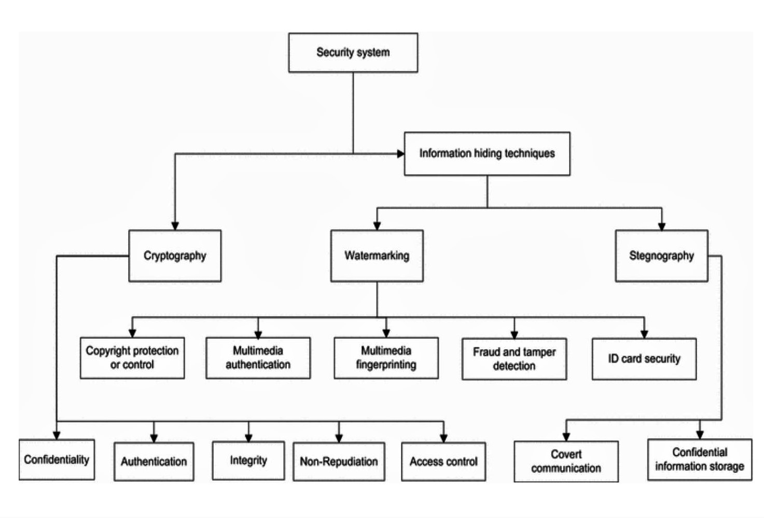Fig: 1 Security System Flow Chart
1.4 Steganography:
Steganography is a technique used to transmit a secret message from a sender to a receiver in a way such that a potential intruder does not suspect the existence of the message. This can be done by embedding the secret message within a digital medium such as image, audio or video. The word steganography is of Greek origin. Steganos meaning “covered or protected”, and graphie meaning “writing”. The first recorded use of the term was in 1499 by Johannes Trithemius in his Steganographia, a treatise on cryptography and steganography disguised as a book on magic. Generally, messages will appear to be something else: images, articles, shopping lists, or some other “cover text” and, classically, the hidden message may be in invisible ink between the visible lines of a private letter. It is a high security technique for long data transmission.

There are various methods of steganography:
• Least significant bit (LSB) method
• Distortion techniques
• Transform domain techniques
• Statistical methods

Steganography under Various Media:
In the following sections we will try to show how steganography can and is being used through the media of text, images, and audio.

Steganography in Text
The example for hiding text in text is: “Apparently neutral's protest is thoroughly discounted and ignored. Isman hard hit. Blockade issue affects pretext for embargo on by-products, ejecting suets and vegetable oils.” Decoding this by taking the second letter in each word reveals the following message: “Pershing sails from NY June 1.”

Steganography in Audio
Because of the range of the Human Auditory System (HAS), data hiding in audio signals is especially challenging. The Human Auditory System perceives over a range of power greater than one billion to one and range of frequencies greater than one thousand to one. Any disturbances in a sound file can be detected as low as one part in ten million (80dB below ambient level). However, while the Human Auditory System has a large dynamic range, it has a fairly small differential range. When performing data hiding on audio, one must exploit the weaknesses of the Human Auditory System, while at the same time being aware of the extreme sensitivity of the human auditory system.
2. Project Scope

The scope of the system is that it provides security for IMAGE files and reducing the Encryption time and Decryption time. The sender using the symmetric key to encrypt and the receiver using same key to decrypt the same Image file. Here, we are implementing Image Encryption by using partitioning, zigzag and swapping and also we using this technique to secure multimedia files. With the use of steganography, the project as a whole offer maximum security. So, sender can encrypt the data to be hidden using both steganography and the image itself can be encrypted. The security hence offer is of higher level.

3. Project overview

The functional overview of the system is as follows:
1. The sender gives the Image file and two keys to the system.
2. The system allows us to choose the image file and the text to be hidden using steganography.
3. The system then generate the binary file for the corresponding Image file by using conversion technique.
4. Apply the partitioning technique and zigzag rule and swapping process in accordance with the key.
5. Convert the binary file to the Image file after applying the three processes and send it to the receiver.
6. The Receiver uses same key to Decrypt the Image files and he apply the partitioning technique and zigzag reverse rule and sapping process.
7. The receiver then extract the text hidden in the image file which is previously embedded using steganography.
4. Global Control Flow

Control flow is the sequencing of actions in a system. It defines the order of execution of operations. These decisions are based on external events generated by an actor or on the passage of time. These are two possible control flow mechanisms.

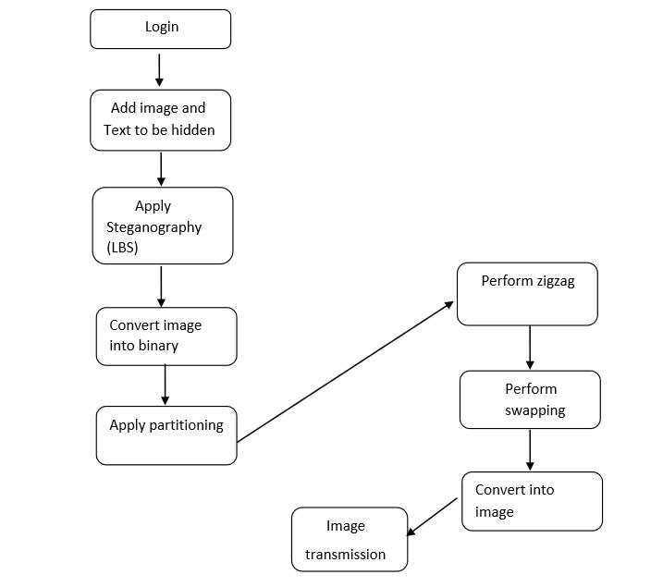
Fig: 2 Control Flow Sequence Flow Chart

5. Algorithms or methods used

5.1 Steganography Encoding and Decoding:
Encoding
In order to hide text in an image, the user must provide the text and a Target Image in which it is to be hidden. Optionally, users may enter or load a text key or generate a key from an image file. When a user key is not provided, a default key is used. We have added an image bar to make choosing images easier. The user may set the source directory, whose contents are displayed as thumbnails in the image bar located on the bottom panel of application. These thumbnails are automatically generated from the specified source directory. The user then selects a target image and loads it for use as the Key Image. The user may also open the Target Image by selecting Open Image under File menu. Additionally, the Key Image may be opened with the Open Image Key command on the Tools menu. The user may enter the text to be embedded in several ways. He or she may type it directly into the text window, open a text file by selecting Open Text under the File menu or use the Edit menu to paste from the clipboard. Loading a text key can be done from the Open Text Key selection on the Tools menu. When user has specified both the target image, and text body, this product is ready to hide the text body within the image. The user may then select Embed Text from the Tools menu. The cipher text and key value will then be input into the steganography and bit placement algorithms, and the Output Image will be generated. After the application has generated the image, the user may then inspect it by selecting the Image tab on the main panel. The user is then able to compare the encrypted target image with the original target image located on the right box of the main window. The user may wish to save the generated image by selecting Save Image or Save Image as under File menu.

Decoding
In order to retrieve the hidden text from the carrier, the user needs to provide a Source Image and any keys used when the source image was generated. Loading the source image file is done similarly to the process of opening a Target Image. If the sender has used the default key, the recipient need not load any keys to the application. The application is not able to identify the presence of the hidden message in images until the actual decoding process is attempted, as the image files are virtually indistinguishable from normal images.Steganography using LSB insertion deals with secure communication between two partiesmainly hiding and revealing the text which is embedded with in a carrier image file. This Application takes three steps to hide the data to make impossible for a third party to view without a key to view or edit the secret message.
1. Steganography algorithm: Steganography is the art of passing information in a manner that the very existence of the message is unknown. The goal of steganography is to avoid drawing suspicion to the transmission of a hidden message. If suspicion is raised, then this goal is defeated. Steganalysis is the art of discovering and rendering useless such covert messages. This can be achieved by the title Least Significant Bit Insertion means hiding the binary converted data into the LSB bits of Digital image file chosen.
2. Security through obscurity: This is useful for adding another level of security to the Steganography by positioning the bits in random order. For example, if we had 4 bits to hide and the space available was more than 4 bits we can position the 4 data bits in a random order not like as 0,1,2,3.
3. Encryption Algorithm: The last level, which is used to highly strengthen the Steganography is encryption level. This means converting the meaningful information into un-understandable form which is nothing but Cipher. The generally used encryption algorithm is one among the advanced encryption standards. Through the use of above three specified algorithms, this product will provide secure communication between parties.
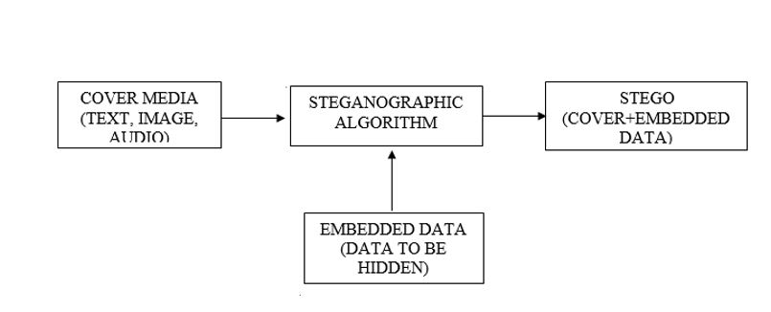
Fig: 3 Steganographic Process Flow Chart
5.2 Least significant bit (LSB) insertion method:
One of the most common techniques used in steganography today is called least significant bit (LSB) insertion. Also called LSB (Least Significant Bit) substitution and it is the process of adjusting the least significant bit pixels of the carrier image. It is a simple approach for embedding message into the image. In this method some information from the pixel of the carrier image is replaced with the message information so that it can't be observed by the human visual system, therefore it exploits some limitations of the human visual system. The Least Significant Bit insertion varies according to number of bits in an image. For an 8-bit image, the least significant bit i.e. the 8th bit of each byte of the image will be changed by the 1-bit of secret message. For 24 bit image, the colors of each component like RGB (red, green and blue) will be changed. LSB steganography involves the operation on least significant bits of cover image, audio or video. The least significant bit is the lowest bit in a series of binary number. In LSB substitution the least significant bits of the pixels are displaced by the bits of the secret message which gives rise to an image with a secret message embedded in it. The method of embedding differs according to the number of bits in an image (different in 8 bit and 24 bit images).
When converting an analog image to digital format, we usually choose between three different ways of representing colors:
➢ 24-bit color: every pixel can have one in 2^24 colors, and these are represented as different quantities of three basic colors: red (R), green (G), blue (B), given by 8 bits (256 values) each.
➢ 8-bit color: every pixel can have one in 256 (2^8) colors, chosen from a palette, or a table of colors.
➢ 8-bit gray-scale: every pixel can have one in 256 (2^8) shades of gray.
For example, let us assume that we want to hide the letter “A” in the image using LSB insertion. The letter 'A' has an ASCII code of 65(decimal), which is 1000001 in binary. Hence, we need to hide “1000001” in the least significant bits of the image bits. Let's say that the pixels before the insertion are:
10000000. 10100100. 10110101. 10110101. 11110011. 10110111. 11100111.
Then their values after the insertion of an 'A' will be:
10000001. 10100100. 10110100. 10110100. 11110010. 10110110. 11100111. (The values in bold are the ones that were modified by the transformation) For 24-bit images the modification can be extended sometimes to the second or even the third LSBs without being visible. 8-bit images instead have a much more limited space where to choose colors, so it's usually possible to change only the LSBs without the modification being detectable.

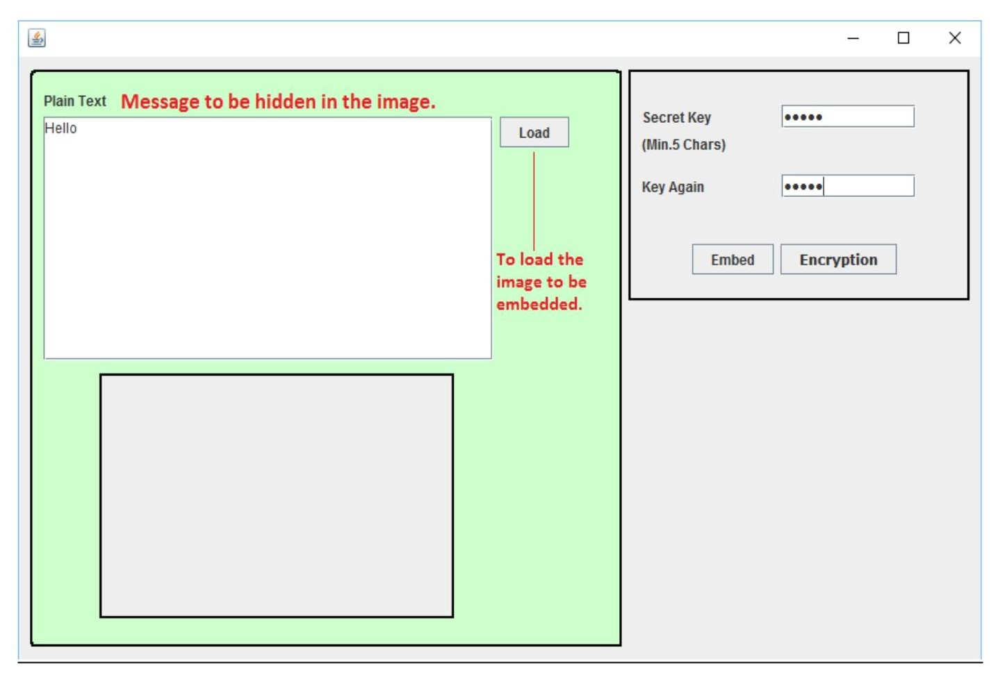
Fig: 4 Hiding Message Into Image
Result:
Fig 4 shows how actually the project interface looks when it is in the embedding phase. The figure shows the java swing windows designed in NetBeans IDE. It has a text area in which the message to be embedded or hidden in the image using LSB algorithm is to be inserted. Load button is used to load the image file in the local computer in which the previously entered text is to be hidden or embedded. The key must be entered in the secret key field which is further used in the extraction of text from the image (kind of authentication).

5.3 Convert into Binary:
The algorithms like partitioning, zigzag and swapping are to be applied in the bits of the image. For these algorithms to be implemented, the image should be converted into binary data in the first place. Hence, the process of encryption starts off with the conversion of chosen image into binary format. For this each pixel is converted into 8 bits or 1 byte.

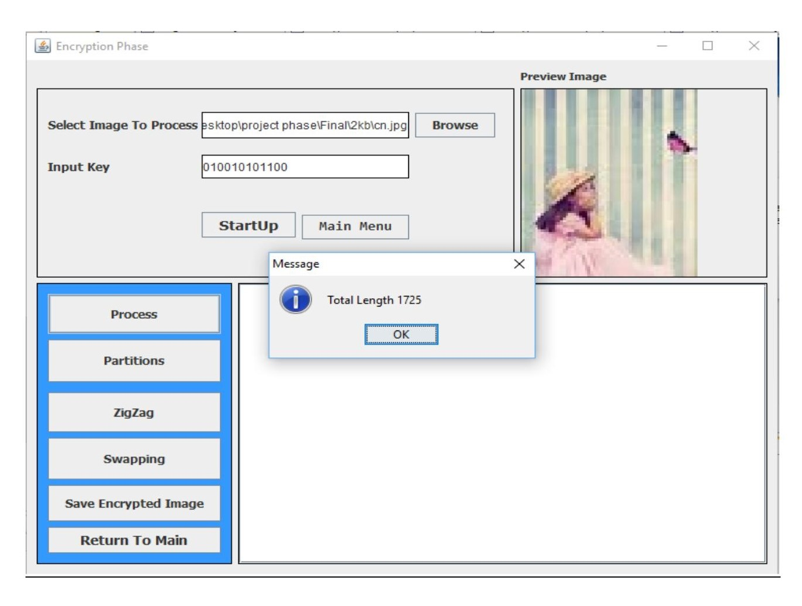
Fig: 5 Conversion to Binary (Encryption)
Result:
The image which is chosen for encryption is of size 1.68 kb which is equivalent to 1725 bytes. Fig-5 shows the result of the image being converted into binary. As soon as the “Process” button is clicked, the image is being loaded into the system and converted into binary format. Also, the dialogue box shows the total length of the image in bytes (*8 gives number of bits).
5.4 Partitioning Method:
Partitioning is possible in various ways. For example, let N = 4 bits. Using 4 bits we can partition bit sequences into 2^4 or 16 parts. Each part will get equal number of bits. If there is m-number of bits in the data file, each partition will get the ceiling of [M/2N] number of bits. So, except the last one each partition will get same number of bits. Let, the data bit is 1000 bits long. As N= 4 each partition will get (1000/2^4 = 62.5 or) 63 bits. And thus in the last or 2Nth partition there will (1000 - 63x15) 55bits.

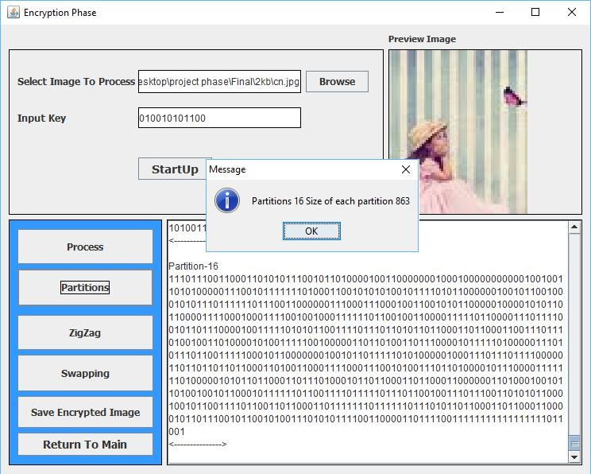
Fig: 6 Partitioning Method
Result:
Fig-6 Shows the project interface in encryption phase. The user chooses the image which is previously embedded with hidden text using LSB algorithm and enter the key. The second process is to do partitions according to the input key. When the button “partitions is clicked, the swing shows the number of partitions and the bits in each partition as below. Also, the bits in each partition is displayed. In the scenario portrayed in the figure below, the first four digits in the input key is “0100” which is nothing but 4 when converted into decimal. Hence, the number of partitions is 2^4 = 16. Each partition gets 863 bits and displayed.

5.5 Zigzag rule:
A line or course that proceeds by sharp turns in alternating directions is known as zigzag rule. By this rule first bit of selected bits will be placed in right position. Again second bit will place in left and third bit will be placed in right position and so on. Here is an example of zigzag:
Let’s select two bit BIT = “1010010100101011”
BITZigzag= [Empty]
First bit of BIT = 1
It will be placed in the right position of BITZigzag
So, BITZigzag= “1”
Second bit of BIT = 0
It will be placed in the left position of BITZigzag.
So, BITZigzag = “01”
Third bit of BIT=1
It will be placed in the right position of BITZigzag.
So, BITZigzag = “011”
Forth bit of BIT= 0
It will be placed in the left position of BITZigzag.
So, BITZigzag = “0011”
After placing all bits BIT will become BITZigzag = “1000110011000111”
By this procedure all bits of selected partition will be converted. Then position of the partitions will also change by swapping.
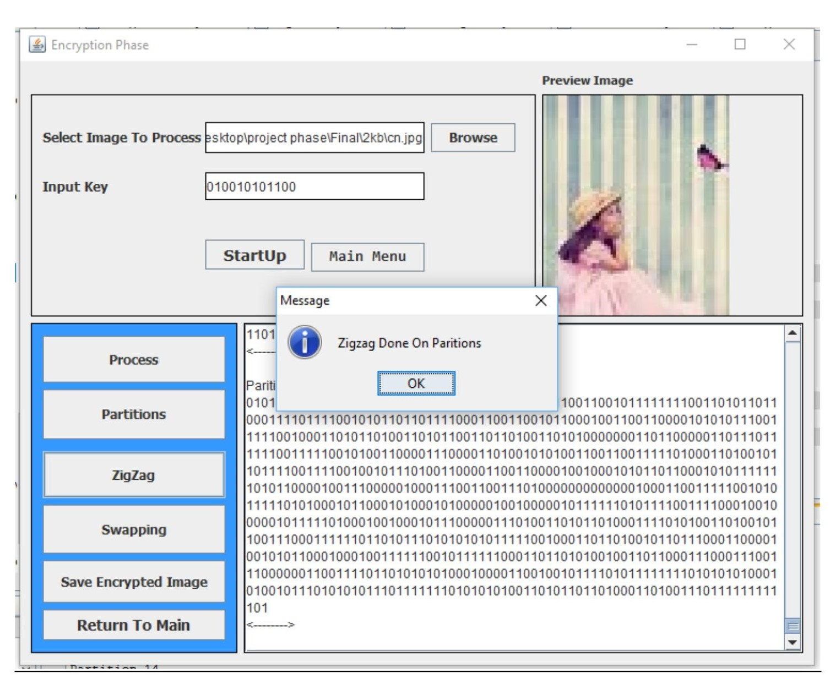
Fig: 7 ZigZag Method
Result:
As said earlier the image has been converted into binary and the binary bits are divided into 16 partitions each having 863 bits. Next process in the encryption phase is to zigzag rule. Zigzag is process is discussed above taking 8 bits as an example. This technique is applied on all the 16 partitions each having 863 bits. Fig-7 shows the output screen when zigzag is applied on the partitions. It also displays all the 16 partitions after zigzag is applied.

5.6 Swapping method:
In our key first i-bit represent the value of N and remaining j-bits used for swapping. Each N number of bits from j will select the partitions for swapping. Number of swap (M) = j/N;
Let, KEY = 0100 1101 0011.
Here i = 4 so j = key-4 = 8.
So, M= 8/4 = 2 swaps.
As, N = 0100 b = 4d there will 2^4 = 16 partitions.
Then j1=1101b = 13d, so 13th partition will swap with the 1st partition.
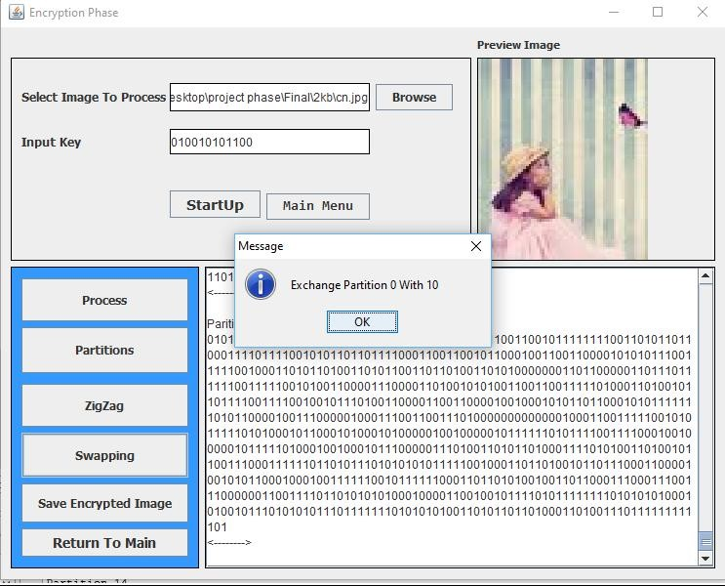
Fig: 8 Swapping Method
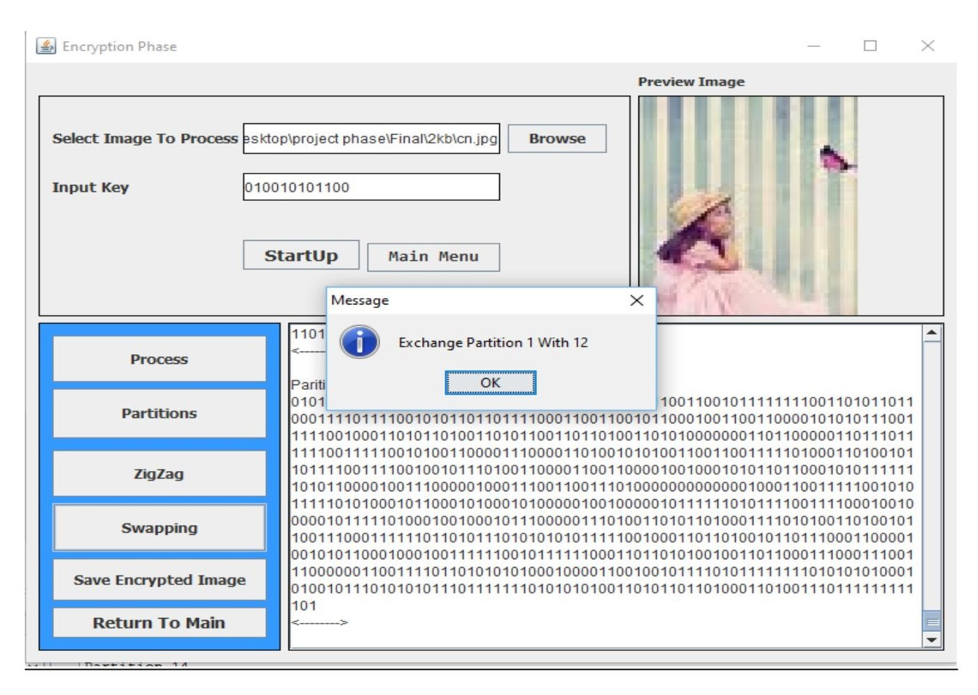
Fig: 9 Swapping Method
Result:
Swapping is a simple technique but when applied along with partitioning and zigzag, offers strength to the encryption phase. Swapping is done according to the input key, 5th bit to 12th or last bit. . As shown in the Fig-8, we have taken the input key as “010010101100”. Where, 5th to 8th bits give “1010” which is 10 when converted into decimal and 9th to 12th bits give “1100” which is 12 when converted into decimal. Hence according to the algorithm, we will swap 0th and 1st partitions with 10th and 12th partitions respectively. Fig-9 shows the output screen when 1st partition is swapped with 12th partition.
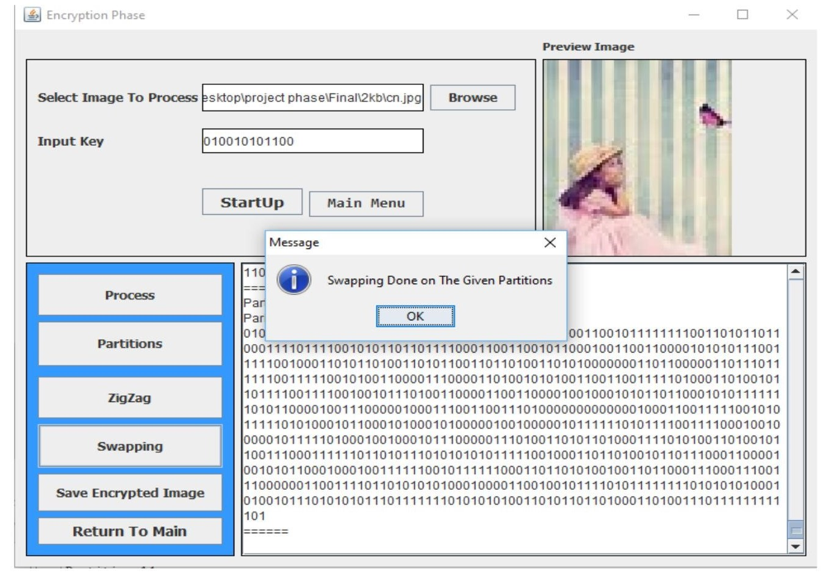
Fig: 10 Swapping Method

Fig-10 marks the end of the encryption phase. The dialogue box shows that the swapping is done on the given partitions. As shown in the figure, when the button “Save Encrypted Image” is clicked, the image on which steganography, partitioning and swapping is done is saved to the location specified in the code. The image’s metadata is preserved in the first 4 pixels or first 32 bits in the binary format. Hence, during swapping, this metadata, which is used by the operation system to recognize that it is an image is disturbed. As the metadata is disturbed, the OS cannot recognize that the file is an image and fail to load the necessary program to open it. As a result the encrypted image cannot be opened by the operating system and it shows that “Windows cannot open this file”.

6. Decryption
Decryption process generally depends on the key. As KEY = i+j, so from first i-bits the value of N can be determined. Then each N-bit from j will select the partitions to swap. For example, when KEY = 0100 1101 0011 and i = 4: 0100 4 = N so there are 2^N or 16 partition. Remaining 8 bits (j) divided by 4 will give M = 2. Now each N or 4-bit will converted into decimal and declare which partitions to swap. As we have got the value of N, following the same procedure used in encryption method number of bits in each partition can be determinable. Then reverse of zigzag rule will apply on each partition. After that, by rearranging the partitions in reverse order) according to the key will return the original data bits.

6.1 Convert into binary:
As decryption is nothing but the reverse of the encryption process, all the processes in the encryption phase has to be reverted in the decryption phase in a particular sequence. To implement the decryption techniques, which deals with the bits of the image, the image must be converted into binary in the first place just as done in the encryption
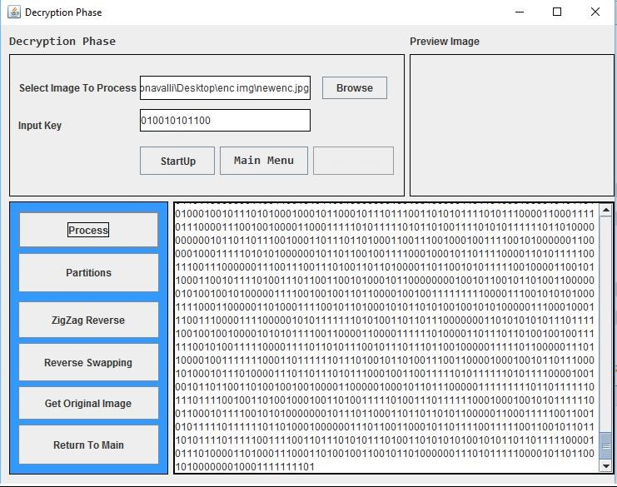
Fig: 11 Conversion to Binary (Decryption)
Result:
Fig-11 shows the project output screen at the starting of the decryption phase. Just as done in the encryption, the image is converted into binary format, where each pixel in converted into 1 byte or 8 bits. In the decryption phase, the image which is saved at the end of encryption phase is loaded with the use of browse button. And the receiver has to enter the input key which is same as the input key used during encryption. Later on, when the “Process” button is clicked, the image in converted into binary and shows all the bits of the image on the screen.

6.2 Partitioning:
The process of partitioning is also done in the same way as done in the encryption phase. Partitioning is done according to the key entered by the receiver which is the one used during encryption. If same key isn’t used, the original image cannot be retrieved as the whole process of decryption is done in accordance with the input key. So, the key entered is “010010101100”. The first 4 bits i.e. “0100” which is 4 when converted into decimal. Hence, the number of partitions will be 2^4=16 partitions.
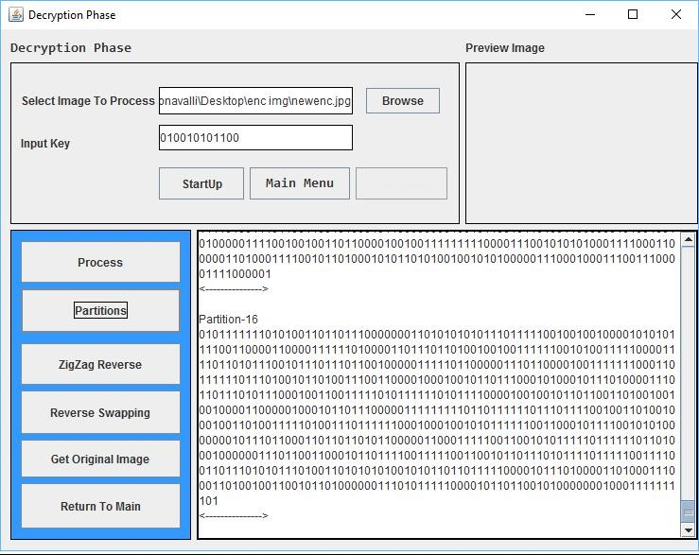
Fig: 12 Partitioning Method (Decryption)
Result:
Fig-12 show the java swing window resulting when the “Partitions” button is clicked. It displays all the 16 partitions on the screen.
6.3 Zigzag Reverse:
Previously, in the encryption phase, zigzag is applied on all the partitions. So, to decrypt, which is nothing but reverting the process of encryption, zigzag performed on the partitions has to be undone. To undo the process of zigzag, we perform the zigzag reverse algorithm on all the partitions. So, after performing zigzag reverse, the partitions come to same state as earlier i.e. the orientation of the original image.

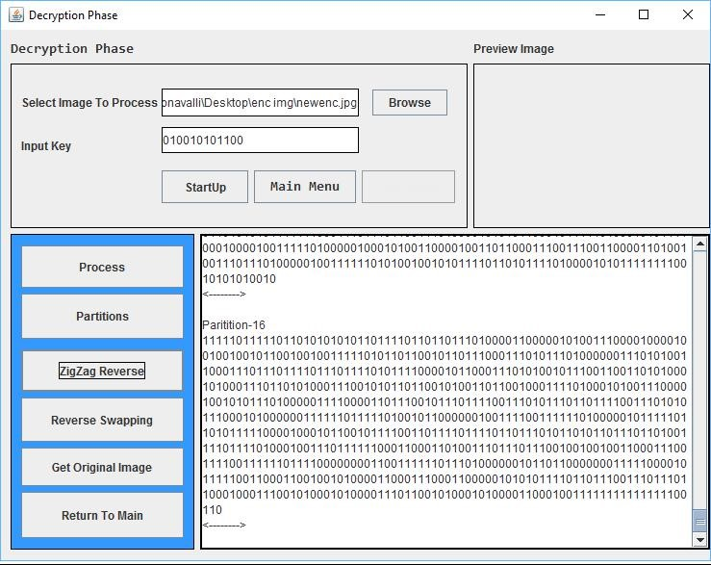
Fig: 13 ZigZag Reverse
Result:
Fig-13 Shows the result screen of the partitions after implementing zigzag reverse. When the button “Zigzag Reverse” is clicked, zigzag reverse algorithm is applied on each partitions undoing the zigzag done on these partitions in the encryption phase.
6.4 Reverse Swapping:
Earlier in encryption phase, swapping was done according to the 5th to 12th bits in the key. In the same way, to decrypt, the swapping done in the encryption phase has to be undone. This undoing is achieved by reverse swapping.

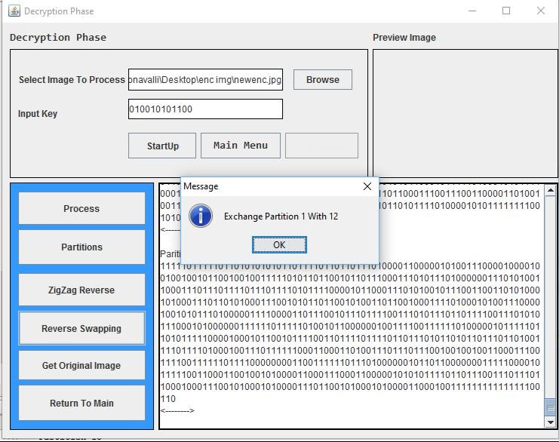
Fig: 14 Reverse Swapping Method
Result:
Fig-14 shows the output when the button “Reverse Swapping” is clicked. During encryption, 0th partition is swapped with 10th and 1st partition is swapped with 12th partition. To reverse this process the same has to be done again. Thus, as a result the partitions align same as in the original image. Finally the bits now have same orientation as of the original image.

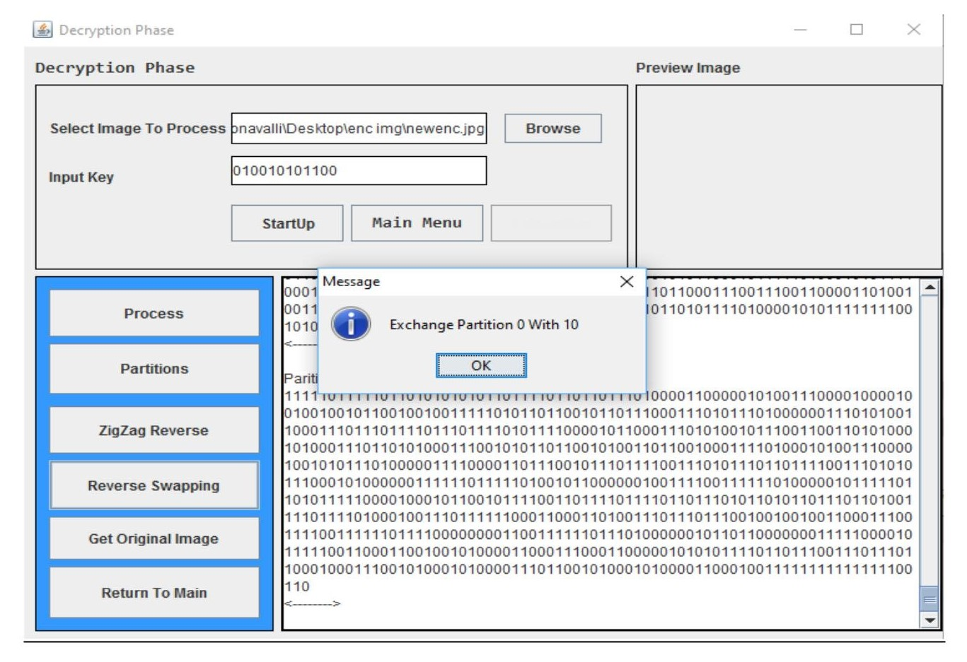
Fig: 15 Reverse Swapping Method
Fig-15 Marks end of the decryption algorithms. The reverse swapping process is completed by swapping 0th and 1st partitions with 10th and 12th partitions respectively. All the decryption processes are implemented to the encrypted image to obtain the original image. Next step is to convert these bits into image and original image is retrieved.
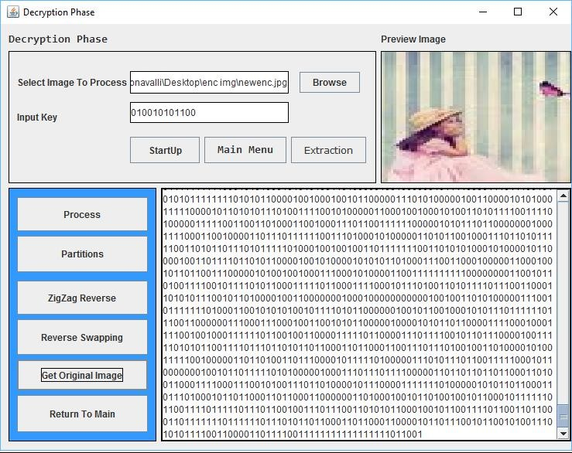
Fig: 16 Reverse Swapping Method
In Fig-16, when the button “Get Original Image” is clicked, the swing asks whether the user wants the preview of the image. When the user clicks “OK”, the preview of the original image is displayed at the top right corner of the swing window. Also, the original image after decryption is saved at a location specified in the code. This saved image is then extracted to retrieve the text message embedded by LSB algorithm.

6.5 Extraction:
Through the processes partitioning, zigzag reverse and reverse swapping, we have obtained the original image from the encrypted image. Initially through the concept of steganography and using technique of least significant Bit (LSB) algorithm, we have embedded some text which is hidden in the image. By retrieving this embedded or hidden text from the decrypted image, we complete every process as planned in the project execution.

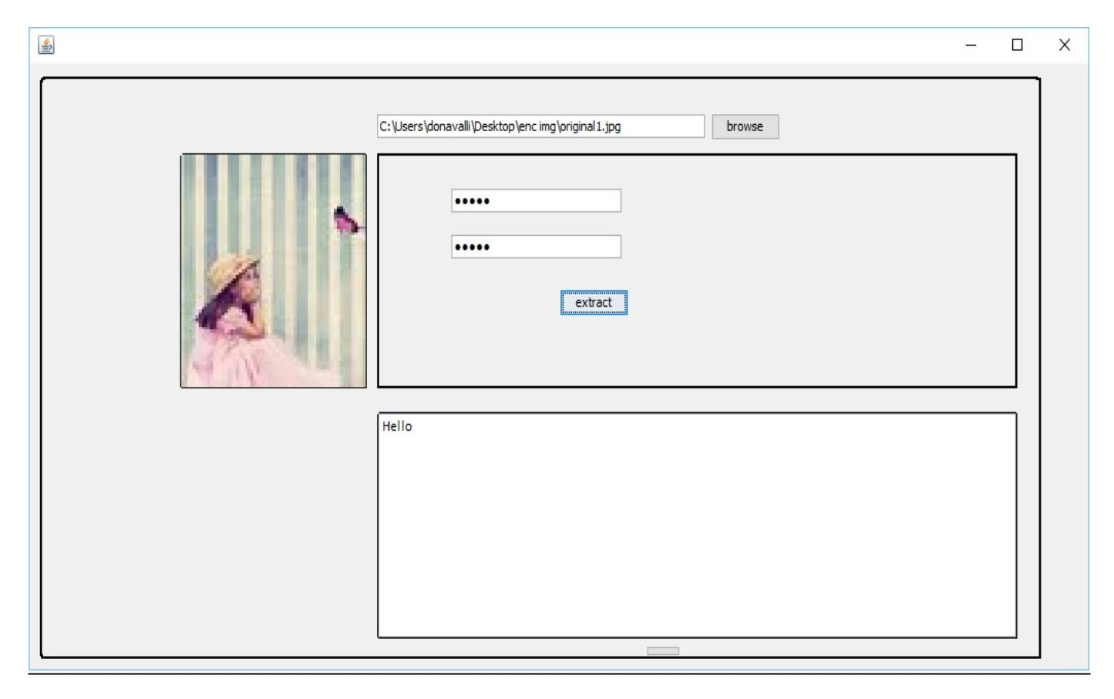
Fig: 17 Extraction Method
Result:
Fig-17 shows the output screen of extraction process i.e., retrieval of embedded text from the image. As shown in the image the browse button is used to load the image which is was decrypted. Then the user enters the user defined key which was used while embedding the text in the image. Now, when the “Extract” button is clicked, the text which is hidden in the image is displayed below.

7. Conclusion:
Image encryption is one of the oldest and efficient techniques which took data confidentiality to a whole new level. In the project we employ algorithms like steganography, partitioning, zigzag and swapping. Here, both the image and the text hidden using LSB algorithm are inaccessible to unauthorized parties. The algorithms used in the project are very simple to analyze but when these are implemented together in a sequence, the process of encryption is very solid and cannot be accessed by the unauthorized parties or intruders. Even when the encrypted image and the key is accessed by the intruders, they cannot access the information as they do not know the sequence of steps undergone during the process of encryption which makes them clueless regarding the decryption process. Though the encryption techniques used in the project aren’t the most complex techniques of image encryption, they are used altogether in a sequence which results in flawless security.

REFERENCES
➢ An Improved Method for LSB Based Color Image steganography Combined with Cryptography Xinyi Zhou, Wei Gong, WenLong Fu, LianJing Jineach copyright 2016 IEEE ICIS 2016, June 2629, 2016, Okayama, Japan.
➢ Schneier, B., Applied Cryptography: Protocols, Algorithms. And Source Code in C, 2nd edition, John Wilen & Sons, Inc., 1996.
➢ L. Tang, "Methods for Encrypting and Decrypting MPEG Video Data Efficiently," In Proceedings of The Fourth ACM International Multimedia Conference (ACM Multimedia'96), pages 219-230, Boston, MA, November 1996.
➢ J. But, G. Armitage, "An Evaluation of Current MPEG-1 Ciphers and their Applicability to Streaming Video, “Australian Telecommunications Networks & Applications Conference 2004, (ATNAC2004), Sydney, Australia, December 8-10, 2004.
➢ X. Liu and A. M. Eskicioglu, "Selective Encryption of Multimedia Contents in Distribution Networks: Challenges and New Directions," IASTED International Conference on Communications, Internet, and Information Technology (CIIT 2003), Scottsdale, AZ, November 17-19-2003.
➢ J. But, G. Armitage, "An Evaluation of Current MPEG-1 Ciphers and their Applicability to Streaming Video, “Australian Telecommunications Networks & Applications Conference 2004, (ATNAC2004), Sydney, Australia, December 8-10, 2004.

